DNS SERVER CONFIGURATION THEORY
- Install and set up a DNS server on your local machine or a VM using BIND (Linux) or Simple DNS Plus (Windows), then create a new DNS zone for the domain musicmania.in.
Answer
DNS server successfully installed and configured on the local Linux environment (Ubuntu 24.04) using BIND 9.
What was done
- Installed BIND 9
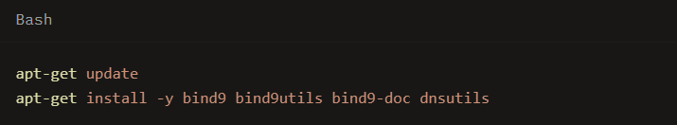
- Created the zone file /etc/bind/db.musicmania.in for the domain musicmania.in:

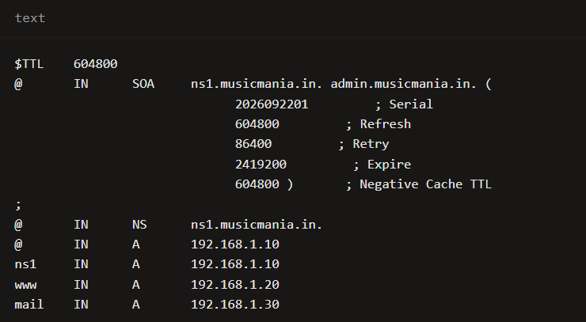
- Declared the zone in /etc/bind/named.conf.local:
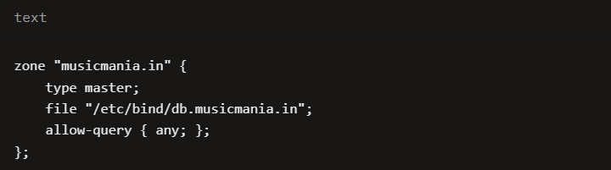
- Updated /etc/bind/named.conf.options to listen on all interfaces and allow queries.
- Validated the configuration and started the named daemon.
Verification (queries against localhost)
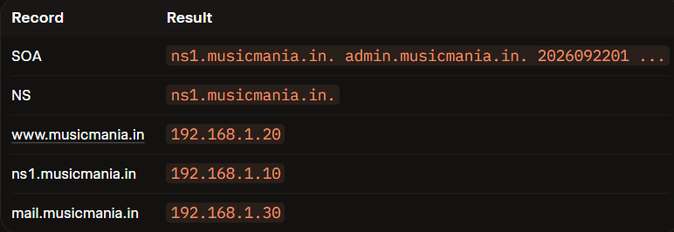
- Simulate a typo by adding a CNAME record for play.musicmania.in that points to www.musicmania.in, then test if accessing play.musicmania.in resolves to the correct IP address.
Answer
Add CNAME for play.musicmania.in BIND9 (Linux)
Edit zone file:
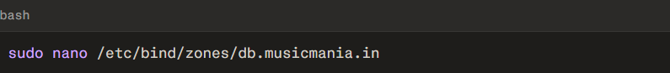
Add:
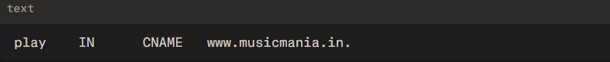
Increment SOA serial, then:
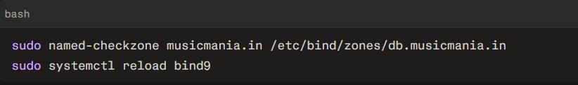
Simple DNS Plus (Windows)
- Open Simple DNS Plus → select zone musicmania.in.
- Right-click → New CNAME-record.
- Name: play
Target: www.musicmania.in
- Save.simpledns+1

Test

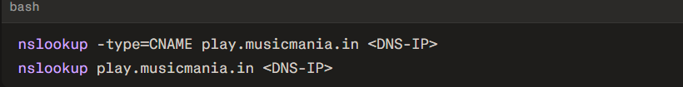
You should see:
- CNAME: play.musicmania.in → www.musicmania.in
- A record: www.musicmania.in → 192.168.1.50
- Your DNS server is not resolving the domain musicmania.in as expected. Document the step-by-step troubleshooting process you would follow, including checking configuration files, restarting the DNS service, and testing with nslookup or dig. Include at least three different troubleshooting commands or checks in your documentation.

Answer

1. Verify Local Configuration Files
Before running network tests, ensure the DNS server's local configuration and zone files are correct.

- Check the main configuration: Open your DNS configuration file (e.g., /etc/named.conf for BIND or /etc/unbound/unbound.conf for Unbound) to ensure the zone for musicmania.in is correctly defined and points to the right zone file.

- Check the Zone File: Open the specific zone file for the domain. Verify that the SOA (Start of Authority), A, and NS records are correct, and ensure the serial number has been incremented if recent changes were made.

- Validate Syntax: Run a syntax check utility to catch typos before restarting the service.

  - For BIND: named-checkconf /etc/named.conf
  - For BIND Zone File: named-checkzone musicmania.in /var/named/musicmania.in.db

2. Restart the DNS Service
If you made changes to the configuration files, or if the service is unresponsive, you must restart or reload the DNS daemon.

- Systemd command:
bash
sudo systemctl restart named
Use code with caution.

(Note: Replace named with bind9 or unbound depending on your specific DNS software).
- Verify Service Status: Ensure the service started successfully and is actively running.
bash
sudo systemctl status named
Use code with caution.
  - Test Resolution Locally and Remotely

Use command-line tools to test if the server is now responding to queries for musicmania.in.
- Test via dig (Detailed Output): Query your local DNS server directly by using its IP address (e.g., 127.0.0.1 or the server's public IP).
bash
dig @127.0.0.1 musicmania.in
Use code with caution.

Look for the status: NOERROR and the ANSWER SECTION to confirm it returns the correct IP.
- Test via nslookup (Alternative):
bash
nslookup musicmania.in 127.0.0.1
Use code with caution.
- Trace the Resolution Path: If local resolution works but external resolution fails, trace the delegation from the root servers down to your domain.
bash
dig musicmania.in +trace
Use code with caution.

  - Inspect System Logs

If the service fails to start or still refuses to resolve the domain, inspect the system logs for deep-dive error messages.
- View live DNS logs:
bash
sudo journalctl -u named -n 50 --no-pager
Use code with caution.

Look for errors like "file not found", "permission denied", or "zone serial unchanged".

To help tailor this documentation further, please let me know:
- What DNS software are you running? (e.g., BIND, Unbound, Windows Server DNS)
- What operating system is hosting your DNS server?

- Add an A record in your DNS server configuration to map www.musicmania.in to the IP address 192.168.1.50, then use the nslookup or dig command to verify the mapping works.
Answer

1) Add the A record
BIND9 (Linux)
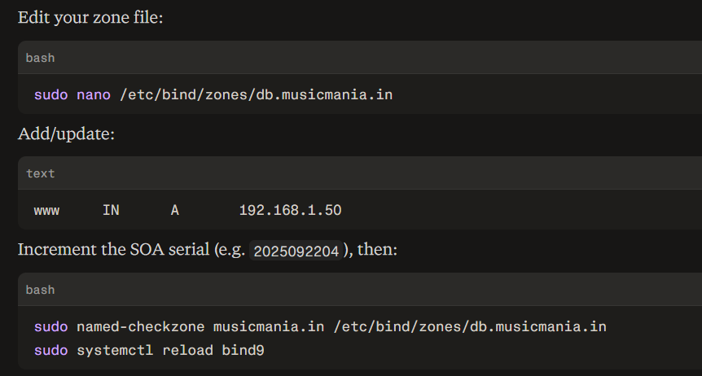

Simple DNS Plus (Windows)
- Open Simple DNS Plus → select zone musicmania.in.
- Right-click → New A-record.
- Name: www
IP: 192.168.1.50
- Save/apply.

2) Verify with nslookup or dig
